The college is equipped with computer labs, physics, geography lab for various streams. The Digital Lounge is the resource centre of e-content which is available for faculties and students of all streams to enrich their knowledge in the field of e-learning. The labs have generators and UPSs for uninterrupted power supply. The campus is enabled with high speed Wi-Fi connections, and the labs are ICT enabled with projectors installed. The labs are also equipped with printers, scanners and photocopy machines and internet connections.

**ICT Enabled Tools for Effective Teaching-Learning Process**

1. Smart Class Rooms: 2
2. Digital Podium: 2
3. Rooms with Projectors: 2
4. Internet
5. Wifi : Internet is extended to whole academic campus with the help of WiFi network.
6. Computing Resources:
7. Computers: ▪

* Academic Purpose: 21
* Non-Academic Purpose: 4

1. Printers: 3.
2. Photocopy Machines: 01
3. Computer Labs:

* Computer lab
* Geography Lab
* Physics Lab
* Digital Lounge

**Location of Smart Class Rooms:**

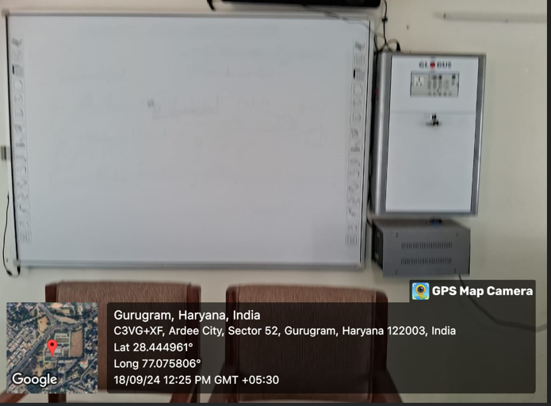

**Room no -3**

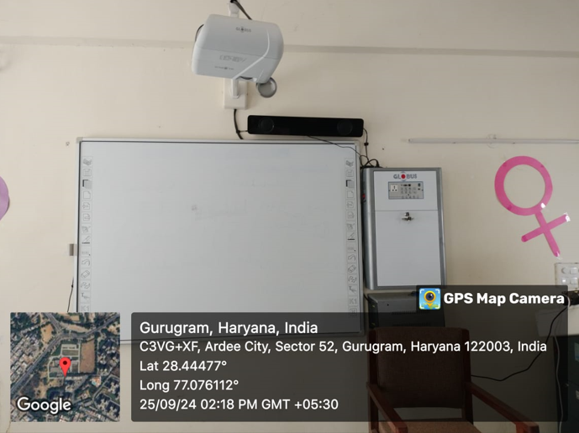

**Lecturer Hall**